**RDBMS Assignment**

Name – Aagam Shah

Email – [Aagam.shah@accolitedigital.com](mailto:Aagam.shah@accolitedigital.com)

Batch – Batch 2 (Banglore)

Question :

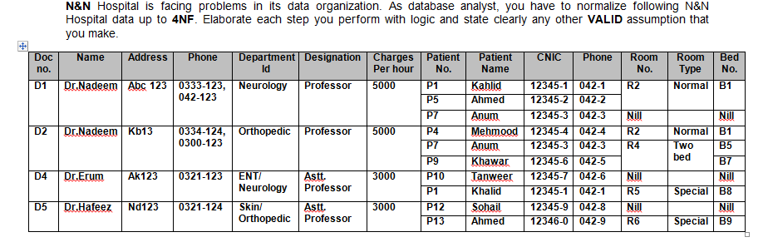

* Normalize the above table up to BCNF.
* Identify and mention the appropriate dependencies in each level of normalization.
* After every normalization level, illustrate the resulting tables with all values
* Elaborate each step clearly and mention any assumption you make to solve the problem.
* Answers can either be submitted as scanned copies of normalization done on paper or as documents where the tables are drawn using tools

Solution

**1st Normal Form**

For a table to be in 1NF it should satisfy the following rules

* There should not be any attributes with multiple values
* There should not be any composite attributes
* All the values must be atomic in nature

Here in our case we can see that Attribute **Phone** is multivalued attribute and even 1 doctor is given 3 patients with their details like name, CNIC and other attributes in case of D1 which should be divided in 3 different item set. We have reduced the table in 1NF by removing all multi value attributes.

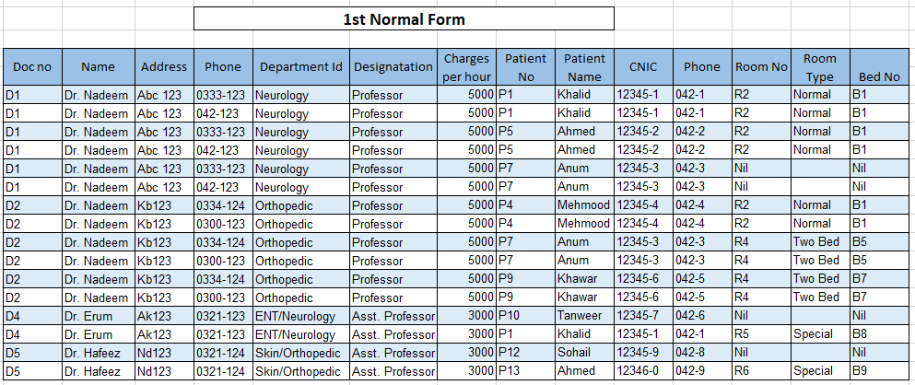

**2nd Normal Form**

For a table to be in 2nd Normal Form it should satisfy the following conditions

* If the table is already in 1st Normal Form
* No non-prime attribute is dependent on the proper subset of any candidate key of table.

In our case we assume

* Patient No can be used to determine
  + Patient Name
  + CNIC
  + Phone (Patient)
* Bed No can be used to determine
  + Room Type
  + Room Number
* Doc No can be used to determine
  + Name
  + Address
  + Department Id
  + Designation
  + Phone No
* Phone No can be used to determine
  + Doc No

Candidate Key – {DocID, Phone, PatientNo, BedNo}

Prime Attributes – {DocID, Phone, PatientNo, BedNo}

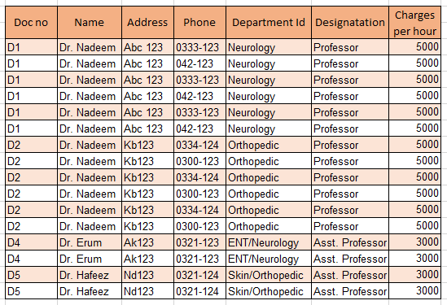

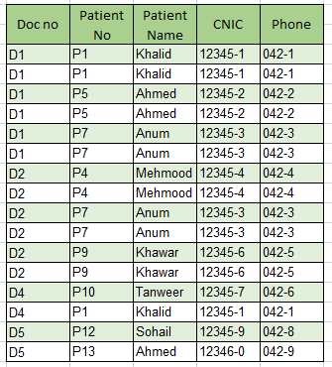 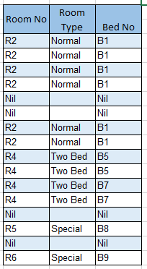 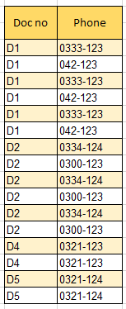

3rd Normal Form

For a table to be in 3rd Normal form it should satisfy few conditions

* It should be in 2nd Normal Form
* There should be no transitive dependency

In our case we have

* Bed No can determine Room No
* Room No can determine Bed Type

This becomes a transitive dependency

So removing that we get

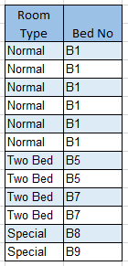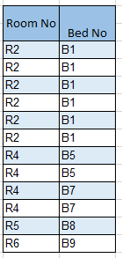

BCNF Form

For a table to be in BCNF form it should be

* In 3rd Normal Form
* For any dependency A → B, A should be a super key.

In our case both the condition are satisfied hence the table is in BCNF Form

Final Table Structure







